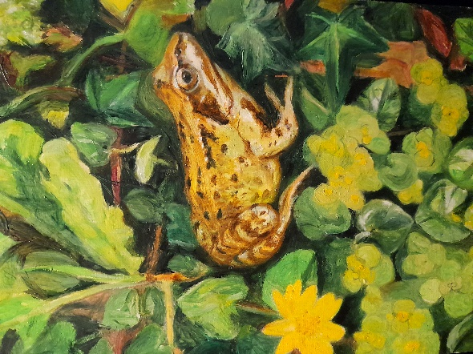
Habitats as Heritage at Kresen Kernow
August residency events
This summer artists Jane Darke and Andrew Tebbs are running a series of workshops, film showings and activities at Kresen Kernow to complement their Habitats as Heritage exhibition, which features 100 paintings of local habitats.

Tuesday August 2
10am-12pm and 1pm-3pm: Drop-in sessions looking at plants through a microscope and drawing what you see, led by Darke and Tebbs (materials provided).

Wednesday August 3
2pm-3.45pm: Join Colin French for this talk about his book Flora of Cornwall. Colin will also discuss the plants of Hayle and Godrevy Towans, and those on granite around Redruth, including the impact of mining which has significantly shaped the flora of this area.

Thursday August 4
11am-1pm: Red River: Listening to a Polluted River– Join poet John Wedgewood Clarkewho will introduce the Red River project and share some of the research that went into the making of his long poem Red River: A River in Pieces. The session will include discussion and an opportunity to write about the Red River and our attitude towards rivers. It will end with a short reading from Red River.
Dr John Wedgwood Clarke is senior lecturer in Creative Writing at the University of Exeter and director of the AHRC-funded project Red River: Listening to a Polluted River. He recently researched and presented the BBC4 documentary Cornwall's Red River.

2pm-3.30pm: Join Darke and Tebbs for this showing of their documentary, shown on BBC FOUR, The Poet Charles Causley (60 minutes) with readings of Causley’s poems about nature

Tuesdays August 9 and 16
11am-1pm: Make photos using plant juices! This Anthotype workshop takes place across two weeks and is led by artist Rachael Jones. Experiment to see which plants, found in the grounds of Kresen Kernow, produce the best photographs. Materials provided. Booking advisable – please attend both sessions.

Wednesday August 10
1pm-3pm: Join director Jane Darke for this showing of her documentary film The Wrecking Season (60 minutes) and explore her collection of natural objects found on beaches around the world.

Thursday August 11
10am-12pm and 1.30pm-3pm: Drop in for this selection of showings of 1960s 8mm film of wildlife in St Eval made by ornithologist and farmer Bob Darke (father of writer, Nick). Subjects include The Food Chain, Pond Life, Cornish Seabirds, Sand Dunes and My Cornwall.

Tuesday August16
11am-1pm: Make photos using plant juices! This Anthotype workshop takes place across two weeks (starting Tuesday 9 August) and is led by artist Rachael Jones. Experiment to see which plants, found in the grounds of Kresen Kernow, produce the best photographs. Materials provided. Booking advisable – please attend both sessions.

Wednesday August 17
10am- 12pm: Shoreline secrets. Join Matt Slater, Marine Conservation Officer at Cornwall Wildlife Trust, and discover his favourite marine creatures and surprising stories about their biology and behaviour. This harsh environment has changed dramatically in the past 20 years and Matt will be talking about these changes and how you can get involved in monitoring and protecting our marine wildlife.

12- 12.30 Biologist Dr Richard Pearce will talk about his study of limpet recovery since the Torrey Canyon oil spill fifty years ago. His study also shows species variation due to climate change.

Thursday August 18
10am-12pm: Join Polly Roberts, poet and nature writer, for this reading from her poetry collection Grieving with the Animals and her novel Together We Evolve, discussing themes of rewilding, nature as therapy and the climate crisis. There will be time for questions and open discussion as well as a short creative writing exercise.

Tuesday August 23
11am-1pm: Drop in for this walk around Redruth identifying trees and drawing them from life led by Darke and Tebbs. Meet at Kresen Kernow.

Wednesday August 24
10am-12pm: Conserving Cornwall’s Cetaceans. Join Cornwall Wildlife Trust for this talk about their work protecting our iconic dolphins, porpoises and whales.

Thursday August 25
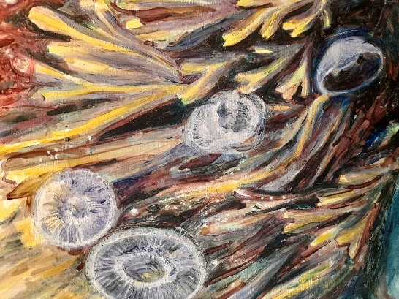
Join Darke and Tebbs for a seaweed sensation! Learn how to identify different species, look at pressed specimens and understand how to preserve them.

Saturdays in August
You are welcome to drop by between 10 and 4pm.
Colour in drawings of insects, birds, plants and animals, traced from the paintings of wildlife by Darke and Tebbs in the Treasures Gallery - crayons provided.
Write a short story or poem about an insect or a bird for Habitats as Heritage on Instagram.

For further information about all events visit kresenkernow.org/events. Please note, there are no refreshments available at Kresen Kernow but you are welcome to bring your own.

